Community Conservation Network
Managing Better Together Network: Management Planning Workshop Report
..........

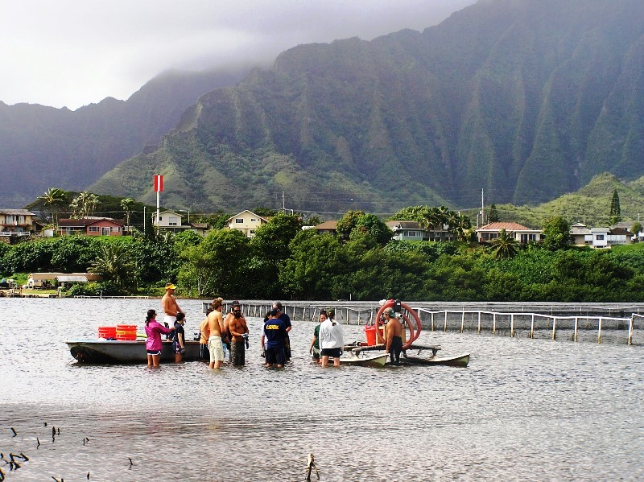
Debbie Gowensmith
February 15 - 18, 2007
Pūpūkea and He'eia
O'ahu
.
.
.
.
.
.
..
.
.

Acknowledgements
Mahalo nui loa to everyone who attended the Managing Better Together (MBT) Network Management Planning Workshop this February. Each of you contributed significantly to this gathering and made it the successful event that it was. We especially recognize the staff and volunteers of the Hui Mālama o Pūpūkea-Waimea, Paepae o He'eia, and Friends of He'eia, who worked so hard before, during, and after the workshop to host us and teach us. Thanks for all your dedication and aloha!

We very much appreciate the time and mana'o of Athline Clark from the Hawai'i Division of Aquatic Resources for giving us the inside scoop on the legislative and rules-making processes (and to her husband for parting with her while he was injured). We also appreciate our friend and colleague Jason Philibotte of NOAA and his co-worker Rob O’Conner, who prepared the wonderful maps for the mapping exercise. Thanks to Hannah Bernard of the Hawaii Wildlife Fund and Eric Co and Manuel Mejia of The Nature Conservancy for driving vans, running to the store, advising, ensuring the comfort of the kupuna, and helping in so many other ways. Thanks also to Taylor Rock and India Clark, who took notes and photographs and assisted whenever they saw a need. In addition, Tiffany at the Pūpūkea Rec Center and the staff at the Honolulu City and County Parks permit office deserve a great big MAHALO for issuing us a permit after closing hours the day before the workshop, when our original venue fell through.

Schrader’s Windward Country Inn provided a beautiful and homey setting that encouraged after-business camaraderie and peaceful sleep. Mahalo nui to the staff for all their work and aloha—and for the wonderful breakfasts and dinner on Friday night. A good workshop is simply not possible without good food, so we also send our many thanks to Chet Naylor and his team at the Waimea Falls Grill, Subway, caterer Tammy Smith who fed us dinner at Paepae o He'eia, and the Windward Poi Bowl for the onolicious grinds.

We especially acknowledge the organizations that provided the funding for this workshop. If these groups did not believe in the positive impact practitioners have when they share lessons with one another, none of this would have been possible. Mahalo nui loa and aloha to the Harold K.L. Castle Foundation for a grant through the Nature Conservancy of Hawaii and to the Hawaii Community Foundation, the National Oceanic and Atmospheric Administration, and the National Fish & Wildlife Foundation’s Coral Reef Conservation Program. On behalf of CCN and the communities represented at this workshop, thank you.

The Managing Better Together Network
The MBT Network is comprised of coastal communities in Hawaii that are working in some manner to enhance the management of the near-shore marine resources in the areas where they live. This Network was first formed in December 2003 at a workshop sponsored by the Hui Mālama O Mo'omomi, The Nature Conservancy, and the Community Conservation Network. Community participants prioritized activities they felt could be done together with other communities to help them enhance their role in managing marine resources. The top three priorities were (1) working to increase the transfer of knowledge from kupuna to youth and to enhance youth involvement in marine management, (2) enhancing the role communities can play in direct management in cooperation with appropriate stakeholders and agencies, and (3) continuing to share lessons and experiences to improve management.

After the first workshop, CCN and our partners set about continuing to bring communities together to share their experiences and build skills in these priority areas. We have now held three workshops: One on the utilization of technology to transfer traditional cultural knowledge of marine resources between youth and kupuna, another on enhancing communities’ role in managing marine resources in cooperation with the State through the Makai Watch Program, and now this one on community-based planning for marine management. Also since then, we have convened two community representatives meetings: one in 2005 on Maui and one in 2006 on Kaua'i. The focus of these smaller, less expensive gatherings is to develop strategies that Network communities can use to improve management; they also include discussion on the role of the Network, fundraising, administration, Network progress, and so on.

The Management Planning Workshop on O'ahu
As more and more communities learned—especially via the June 2006 MBT Network Community Representatives meeting on Kaua'i—about the possibility of developing regulations for their areas, CCN received more and more requests for the tools needed to create and substantiate regulations. This workshop was developed out of those requests and therefore focused on management planning. We also briefly discussed the rule-making process of the Department of Land and Natural Resources (DLNR) and the process of policy creation in the State legislature. Sixty-nine attendees represented 16 communities around the state, the Hawaii Division of Aquatic Resources, the National Oceanic and Atmospheric Administration, and several nonprofit agencies. The workshop, held on O'ahu from February 15-18, 2007, was hosted by the Hui Mālama o Pūpūkea-Waimea, the Paepae o He'eia, and the Friends of He'eia.

General Conclusions
- The process of developing a management plan is helpful to communities regardless of whether they plan to propose to the DLNR new rules for their areas. The plan clarifies and communicates goals and objectives, and it leads to targeted activities that are most likely to make the desired difference to the resources. However, each community that wants to develop a management plan needs to create their own strategy and timeline—there is no such thing as “one size fits all” with management planning.
- Mapping is a great exercise that gets people interested and involved. Hawaii has been well-mapped by state and federal agencies, so communities can build upon what those agencies have already done. There are many different types of mapping, but even simply taking a walk along the shoreline and marking down natural and socio-cultural resources can help the community focus its efforts. You can also develop computerized maps with different layers so that different information is available for viewing by different viewers. In any case, communities should be cautious with maps so that information that they wish to remain private does not become public.
- Experiences such as pulling alien algae, building wall, and opening fish to examine the contents of their stomachs engages participants in learning, opens them to new possibilities for projects at home, and provides service to the hosting group. Plus, everyone simply enjoys the hands-on nature of those types of activities.
- Perhaps the greatest value of the MBT Network is in getting people together to learn from each other. Many communities have expressed a desire to manage their areas in a way that utilizes both contemporary and traditional management methods. The group at the Paepae o He'eia is doing just that. Our hope is that other groups can apply some of the experiences from Paepae o He'eia to their own places; we also hope that communities will continue to communicate questions and ideas with one another between the formal gatherings.
- Because the political and legislative process can be complex, it is ideal for someone in the community to focus on that aspect and help the rest of the community navigate the process.
- The Land Board is an important policy-making and policy-reviewing body, so it’s important to keep abreast of what they are doing and to build relationships with people representing your island on the Land Board.
- When reviewing legislation, it’s important to read bills with the community and discuss their meaning together. Consider whether what is being proposed is a threat or an opportunity. Consider whether what is being proposed fits your values—for example, is it place-based and community-driven or is it generalized and top-down? Does the legislation honor kupuna and ancestors in word and deed? What might be the impact on future generations?
- The participation of NOAA and DAR in the MBT Network is positive. Agency staff and community members each need to better understand what the other is doing and can do. They often need to build relationships and work together.
- CCN tries to cover too much during our short time together. It has been suggested that we instead go deeper with fewer items.
- The groups that comprise the MBT Network have made a lot of progress since the Network’s inception. Communities are actively involved in implementing projects. A conversation for the near future is whether the Network should become its own non-profit organization. Most people agreed that, at the very least, the Network needs a Hawaiian name. Network participants also agreed that continuing to meet face-to-face on a regular basis is crucial.

Appendix 3 includes brief notes captured from each day’s discussions.

Thursday, February 15: Pa'ina at Schrader’s Windward Country Inn
We began this gathering with a pa'ina on Thursday, February 15. After a pule led by Butch Helemano, we feasted together near the shoreline at Schrader’s Windward Country Inn, where everyone stayed for the weekend. By beginning with a traditional meal together, community members were able to reconnect with old friends and form new connections in a relaxed, friendly atmosphere.

Friday, February 16: Pūpūkea
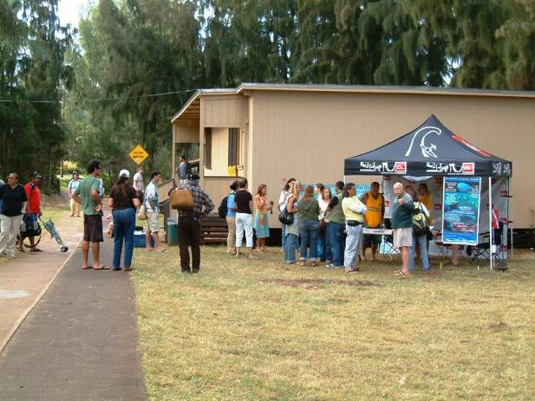
We spent Friday at the Pūpūkea Recreational Center on the North Shore, focusing on tools for management planning. After an opening pule and welcome led by Butch Helemano, participants introduced themselves and provided brief updates on their projects. Scott Atkinson highlighted some Network participants’ successes such as the formation of two Community-Based Subsistence Fishing Areas, six new Makai Watch programs, the adoption of Makai Watch by the Land Board, and a HUD grant received by Ho'okena and Miloli'i.
Deva Gatica

A reoccurring theme in the community updates was the need to integrate traditional concepts and practices into modern management efforts. Traditional knowledge and values provide the appropriate foundation with concepts such as ahupua'a-based management, which recognizes the connection of makai and mauka and the unique characteristics of each place. A number of participants also mentioned the need to integrate Hawaiian spiritual practices with conservation efforts and to recognize that the Hawaiian communities are part of a larger Pacific Island culture. Starting with this awareness, contemporary management techniques that address current realities can be integrated.

Management Planning: Each participant received a binder of information, including a management planning workbook. We covered the following:
- The importance of preparing a management plan
- What comprises a good management plan
- How to know whether you are ready to prepare a management plan
- Getting organized to begin a management plan
- How to do a stakeholder analysis

We also suggested a community process for management plan development, though each community should amend the process to fit their particular circumstances. The suggested process is included as Appendix 4. We also explored one of the first steps to management plan development—the creation of a conceptual model, which illustrates the community’s vision for the area, the threats to that vision, the opportunities that exist, and potential strategies to move the community toward the vision. An example conceptual model was included in the binder.

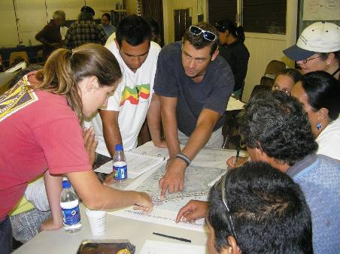
Mapping Exercise: One of the initial and important steps in management plan development involves mapping the natural and socio-cultural resources that the community is including in the management plan. Participating communities were provided large satellite maps of their areas, and they worked to identify the locations of natural resources such as habitats and important species and socio-cultural resources such as sacred or historical sites. We also discussed the potential need for a community to safeguard some information—the location of important ko'as, for example. Different paper maps can be created for different audiences, or computerized maps can be developed with several layers so that different viewers have access to different information.
Debbie Gowensmith
Hā'ena, Kaua'i group mapping with NOAA’s Jason Philibotte

The purpose of part of the afternoon’s mapping exercise was to give back to the Hui Mālama o Pūpūkea-Waimea. Participants formed groups and, with maps of the Pūpūkea Marine Life Conservation District in hand, separated to map different sections of the area. Unfortunately, a late afternoon downpour put an early end to the activity.

Saturday, February 17: Paepae o He'eia
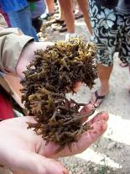
The purpose of Saturday’s session at Paepae o He'eia in Kāne'ohe was threefold: (1) to continue the discussion of management planning while learning about and in a different area’s context, (2) to learn about the integration of traditional and contemporary techniques that the staff at the Paepae o He'eia utilizes to manage the fishpond, and (3) to participate in the work of managing the fishpond as a way of giving back to that community.

Fishpond Tour and Mālama 'Aina Projects: After a pule by Mahina Paishion Duarte of Paepae o He'eia and introductions, fishpond staff led the group on a tour of the fishpond, highlighting the cultural importance, ecology, traditions, and management approaches used. We also learned about some of the current threats to the health and maintenance of the fishpond, including alien algae (see photo to the right).
Maka'ala Ka'amoana

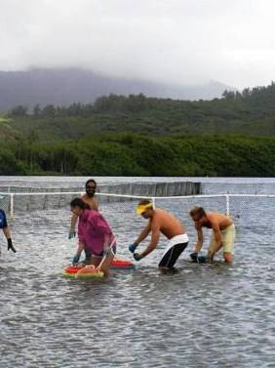
Once we understood the context of the place, we formed several groups to participate in mālama 'aina projects. One group worked on invasive and alien algae removal within the fishpond using hands and nets in addition to a “mini-sucker,” which was developed by The Nature Conservancy to “vacuum” the alien algae from the water. Another group repaired part of the fishpond wall, moving rock and coral into its proper place.
Debbie Gowensmith
About two hours of work yielded about two tons of invasive Gracilaria salicornia and repairs to an approximately 40-feet stretch of the pond's ancient seawall. Mahina noted that the fishpond was constructed almost 800 years ago; she thanked everyone for the aloha we put into the fishpond, which will last for another thousand years.
Removing alien algae

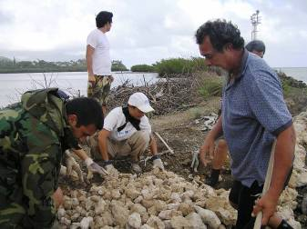
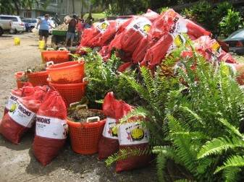
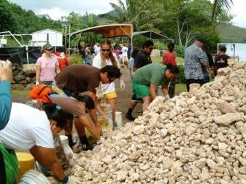
India Clark
Deva Gatica
Debbie Gowensmith
Alien algae removed from the fishpond
Moving coral and rock for the fishpond wall
Rebuilding the fishpond wall

Management Planning: The first afternoon session picked up where we left off yesterday, with discussions on zoning and rule-making and SMART objectives as part of the community-based management planning process.

As was discussed the previous day, mapping helps the community gain a clear idea about the resources they are trying to manage and where those resources are. The community can later use those maps to help them make decisions regarding zones and rules. For example, if a particular area is especially important for traditional community fishing, it may be zoned as an area exclusively for that activity. We stressed the importance of including different types of areas to ensure that the diversity of species and their life cycles are considered, that monitoring and enforcement can be provided, and that the interests of different stakeholder groups are represented. In short, zones should help communities reach their objectives while being logistically feasible; they should be realistic but ambitious.

Of course, zones should be directly related to the objectives of the managed area. We discussed how to create and use SMART objectives, which are specific, measurable, achievable, relevant, and timely. Participants practiced creating SMART objectives for their areas before discussing how objectives can also be used to create measures that help the community assess progress.

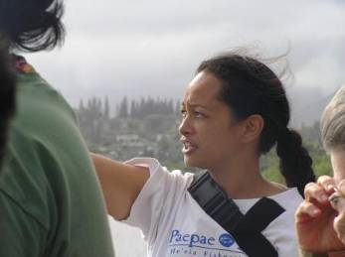
Traditional Management Methods: The final portion of the day provided a hands-on opportunity for attendees to participate in some of the traditional and contemporary management practices utilized by Paepae o He'eia. If a fishpond is managed properly, predators are eradicated and eaten to protect the native keiki fish. We learned about the moon calendar study that students at the fishpond completed the previous year, and we then had a chance to participate in the monitoring practices ourselves. One group monitored the quality of the water in the fishpond; other groups opened fish and examined the gonads and contents of the fishes’ stomachs; and other groups monitored crab populations through trapping them in transects. Invasive crabs were caught for the evening meal, but indigenous crabs were caught, measured, recorded, and released.
Debbie Gowensmith

The day was capped with a wonderful meal on-site that included moi and alien crabs from the fishpond along with alien limu that had been pickled and added to a salad. The poi and salad greens came from local farms, highlighting the realities and possibilities for a healthy and sustainable diet provided through mālama 'aina practices.

Sunday, February 18: He'eia State Park
Communities are affected by and can affect policy through the legislative process and through the Land Board, so the purpose of the half-day session at He'eia State Park was to empower communities to be involved in these arenas that can both help and harm their efforts.

The Legislative Process: General information about the process a bill goes through to become law was provided in the binders participants received, and we reviewed this information together. Tools communities can use to track bills and ensure that their voices are heard were highlighted. Network participants such as Henry Chang Wo and Maka'ala Ka'aumoana, who have participated in the legislative process on behalf of their own communities, contributed heavily to this discussion.

The DLNR and the Land Board: Athline Clark from the Hawai'i Division of Aquatic Resources (DAR) explained the process of working with the DLNR and its Board. She discussed the process of creating new rules for an area; and a diagram of this process is included as Appendix 5. Participants were able to ask many questions of Athline about what can be a confusing and heavily bureaucratic process.

After the presentations, participants formed two groups to discuss two particular bills. One group studied a bill that would create a statewide Aha Moku Council, and the other group studied a bill that would affect fisheries regulations for the state. Groups learned how to read the bill through the lens of whether it contains potential threats or potential opportunities (or both) to what they want to do. The group studying the Aha Moku Council bill felt that it could provide good opportunities, while the group studying the fisheries bill felt that it presented serious threats to their projects. Network participants agreed that CCN could provide a service by sending updates about policies that could affect their marine projects.

Before the closing pule and goodbyes, CCN invited all participants to contribute their thoughts on how this Network has been helpful and how it can improve. Those notes are included in Appendix 3.

Conclusion
We were excited to see so many new faces at this workshop. Each time we gather, there is interest from new communities and from newly involved members of communities that have previously participated. It was also exciting to review what has happened since the first gathering in 2004. Through communities’ persistence and strength, many have moved from desire to idea to plan to implementation in a short time.

During and after each Network gathering, we hear from you that these have become motivating and empowering experiences that you look forward to. We hear that you value coming together to hear about what other communities are doing and to learn from and teach each other. We have also heard that some people believe it may be time in the near future to formalize the Network as its own entity. This could be one of the focused discussions during the next Network community representatives gathering. From CCN’s perspective, we are happy to play whatever role you would have us play; we are also happy to play no role at all, if the time comes when another organization wants to convene and facilitate the Network’s gatherings. Until then, we will continue our efforts to raise funds to support the Network in whatever way we can. We are also committed to improving the Network and responding to the lead of its community representatives.

We understand that it is important for you to see how the funding we receive for these gatherings is being spent, so we have again included the financial statement in this report. (See Appendix 2.)

We again thank the sponsoring organizations, the host communities, and all the participants for a wonderful workshop. We are looking forward to seeing you at the next gathering. Aloha 'oi.

Appendix 1: Participants List
Communities | People | Phone | Mail or Email
Kauai:
Hanalei | Maka'ala Ka'aumoana | 808-828-1205 | hanaleiriver@hawaiian.net  makaala@hawaiian.net
 | Harry Ka'aumoana | Same as above | Same as above
Hā‘ena | Jeff Chandler | 826-6295 | PO Box 447, Hanalei 96714
 | Moku Chandler
 | Atta Forrest |  | aforrest@ntbg.org
 | Noah Ka'aumoana-Texeira
 | Megan Juran |  | nahoawahine@hotmail.com
 | Lahela Correa |  | lghaena@ntbg.org
 | Kawika Winter |  | kwinter@ntbg.org
Waipā | Lea Weldon |  | Lea_w007@hotmail.com
Oahu:
Ewa Beach | Henry Chang Wo | 225-4933  689-7229 | 91-1091 Hanaloa St.  Ewa Beach, HI 96706
Waianae | Eric Enos | Via Ka’ala Farms at 696-4954 | holopono@pixi.com
 | Kina Mahi | Same as above | kmmahi@yahoo.com
Pūpūkea | Butch Helemano | 292-4294 | helemanob001@hawaii.rr.com
 | Joe Cicak | 808-206-8350 | Joe_Cicak@excite.com
 | Cora Sanchez | 383-9220 | corasanchez@hawaii.rr.com
 | Bob Leinau | 638-7010 | leinaur001@hawaii.rr.com
Maunalua | Alyssa Miller | 228-0027 | greenwaveproductions@gmail.com
Paepae o He'eia | Mahina Paishon Duarte | 236-6178 | paepaeoheeia@hotmail.com
 | Hi'ilei Kawelo | Same as above | Same as above
 | Anuenue Punua | Same as above | Same as above
Kailua | Chuck Burrows |  | chuckb@hawaii.rr.com
UH Graduate Students | Taylor Rock |  | rock@hawaii.edu
 | India Clark |  | indiadawn@gmail.com
 | Ling Ong |  | ongl@hawaii.edu
 | Vanessa Konno
Resource People Oahu: CCN | Debbie Gowensmith | 528-3700 348-1694 | debbie@conservationpractice.org
 | Scott Atkinson | 342-2335 | scott@conservationpractice.org
 | Andrea Bertoli | 735-6530 | andrea@conservationpractice.org
 | Deva Gatica |  | ojai.deva@gmail.com
 | Supin Wongbusarakum |  | supin.CCN@hpbizmail.com
 | Eric Co (TNC) |  | eco@tnc.org
 | Manuel Mejia (TNC) |  | mmejia@tnc.org
 | Emily Fielding (TNC) |  | efielding@tnc.org
 | Koa Shultz (TNC) |  | kshultz@tnc.org
 | Athline Clark (DAR) | (808) 587-0099 | Athline.M.Clark@hawaii.gov
 | Petra MacGowan (DAR) | (808) 587-0098 | Petra.MacGowan@hawaii.gov
 | Carlie Wiener (DAR) |  | carlie_wiener@hotmail.com
 | Jason Philibotte (NOAA) | (808) 944-2236 | Jason.Philibotte@noaa.gov
 | Meghan Gombos (NOAA) | (808) 532-3961 | Meghan.Gombos@noaa.gov
 | Michael Lameier (NOAA) |  | Michael.Lameier@noaa.gov
Maui:
Ahihi Kinau | Matt Ramsey (DOFAW) | 264-2029  223-4404 | Matt.Ramsey@hawaii.gov
 | Anthony Moreno |  | ahihiboyz@yahoo.com
 | Johanna Kamaunu |  | jkamaunul@yahoo.com
Honolua Bay | Liz Foote |  | LFoote@hawaii.rr.com
Resource People Maui: | Hannah Bernard | 280-8124 | wild@aloha.net
Molokai:
Kaunakakai | Noelani Lee |  | kahonuamomona@mac.com
 | Mervin Dudoit |  | Same as above
 | Malia (student) |  | Same as above
 | Barbara (student) |  | Same as above
Big Island:
Ho‘okena | Damien Kenison | 987-9149 | namamo@yahoo.com
 | Glendora Kenison | Same | Same
Honaunau | Healani Cahill | 328-2687 | sye@aloha.net
 | Leinani Loa |  | paeai@hawaiiantel.net
 | David Loa
 | Linda Morgan
 | Dona Lavorin
 | Carla Freitas
 | Barbara Navas
Ka‘u | Bob DaMate |  | Same as below
 | Leimana DaMate | 808-640-3205 | leimana@fastnethi.com
Kealakekua | Cheryl Matthews | (808) 322-4860 | cmatthew@hawaii.edu
 | Mahina (student) |  | Same as above
 | Kainalu (student)
Resource People Hawaii: | Luna Kekoa (CCN) |  | luna@conservationpractice.org

Appendix 2: Financial Report
2007 INCOME for MBT Network Events
Harold K.L. Castle Foundation | 21,500.00
Hawaii Community Foundation | 5000.00
National Oceanic & Atmospheric Administration | 5000.00
National Fish & Wildlife Foundation | 2500.00
Total income | 34,000.00
EXPENSES for Management Planning Workshop
Air transport | (4472.58)
Ground transport | (2503.39)
Lodging | (11,161.05)
Meals | (5251.30)
Supplies, venue fees, etc. | (1621.83)
Total expenses | (25,010.15)
TOTAL remaining for 2007 Network Community Reps Meeting | 8989.85

Appendix 3: Notes from the 2007 MBT Meeting
Community Introductions and Updates

Hā'ena

- “System has been abused and used against us.”
- Historically and culturally we have the tools we need to manage our resources.
- How did our ahupua'a function? We have lost our lands, and we need to re-learn about them.

Pūpūkea

- We need to use No'a which means “free for all—not just you.” This is a different approach than kapu.

Ka'ala Farms:

- “We need to start young, from the womb.”
- “We need to bring back waters into our streams, like blood returning to the body.” But we also need to leave some water in the mountain. These are the life-giving waters of Kane. It is our kuleana.”
- “We need to bring back our ancestors in the form of plants.”
- “We need to kapu the ocean, submerged lands and bring back the fishing canoe. We should also use modern methods and science as our kupuna would have.”
- “We need all elements of knowledge about the water whether it is mauka or makai. We are all doing the same thing.”

Ho'okena

- “We are the “other last Hawaiian fishing village.”
- CCN has been very consistent and fair in their support.
“We need to establish a modern ahupua'a system using our traditional fishing zone.”
- “It is hard because everyone is spoiled. They are used to going anywhere they want and taking whatever they like.”
- “We still have our fishing canoe. To me that is our link to the past. If we don’t use them, that is one way of losing our culture.”
- “We look makai and a bulldozer is pushing along our backs. We need to protect both the land and the coast. We can not just focus on the ocean.”
- “We need a common ground. We just need to do something now. Not only for our fish, but also for our culture.”
- “CCN, TNC, NOAA have all helped me to become what I am today—a dangerous Hawaiian.”

Honaunau

- “We have one of the last fishing villages on the island.”
- “When you jump in a canoe, you need to know who is jumping in with you.”
- “Instead of responding in a negative way, we need to try to do things in a positive way.”
- “We are working with the immersion schools. We are starting it and our children will continue it.”

Ka'u

- “CCN has helped us focus our efforts.”
- “We need to frame it in the reverse situation. We don’t need to restore our area—it is already pristine. We just need to protect it.”
- “We are the last untouched Hawai'i. We have 80 miles of coastline and only 3 vehicular access points. We have 147 villages along the coastline. Our wahi pana, our stories, our heiau are still intact. It is like our ancestors just recently walked away.”
- Our moku doesn’t have invasive plants like Keawe.
- “When you dial 911 it takes 2 hours for someone to make it out. We have to be self-sufficient.”
- “We try to do things the way they have always been done. 25% of our food is from the grocery market. We grow, fish and hunt for everything else.”

'Ewa

- “Culture dies when you lose your natural resources.” We are looking at the genocide of my ahupua'a.”
- “I fight for the seaweed. No seaweed means no fish.”
- “All fish need the brackish water at one stage of their life.”
- “The ocean is where the magic happens, where life begins.”
- “I don’t know how we stop it or the right medium to address development destroying our resources.”
- “We can present our case, we can have a good cause but then the developer may still win. We are seeing a lot of rubber-stamping. They just granted a ‘No Adverse Impact to the Ocean’ for a storm drain that is going in close to the shore.”

Maui

- We are feeling stuck with defining “who is the community” and how large do you make the stakeholder groups?

Moloka'i

- “Meeting allows us to connect the dots and help each other. We are not just going away with our own knowledge.”

Eric Enos’ report on the Our Sea of Islands Conference

- It is very important that we view this as a whole Pacific Island network.
- UNESCO/ NOAA conference showed that the issues we are facing are ones that are shared throughout the Pacific.
- “It is encouraging, strategies are emerging.”
- “Knowledge was driven out of us. The answer is to bring the knowledge back.”
- “If you take the spirituality out of work, it has no foundation.”

Ka’u

- “Hawaiian science is how we live our culture.”
- “We need to start educating people that ahupua'a runs from the sea soil up to the mountaintop, not the other way around. This was stated in the ahupua'a 1868 Kingdom Law.”
- “All trees, plants and food had fish names.”

Misc

- How can communities share lessons, especially about what the legislators want. If one community is turned down, how can we help each other so that the next one is accepted?
- We need to use an inter-community strategy for applying for grants and legislation.
- Scott: We have 3 MMAs with legislative support. We have six more Makai Watch programs. We have our first Mauka watch with the Hā'ena community. HUD has funded the development of two new community centers.
- Scott: The idea is to share or give back to the hosting community by doing active work programs: This is how the networks operate.
- “We do care about our resources. We just forgot and now we are forcing people to remember. The key element is the gatherings.
- We need to take advantage of our DLNR rangers (Matt and Megan).

Friday discussion about Management Planning

- The process of creating a management plan was explained step-by-step with a process flow chart created for a sample community
- The process of conceptual modeling was explained using an example from Pūpūkea.
- Threats and problems in the area are recorded with input from the community.
- Opportunities in the area are identified in relation to the threats and problems.
- Objectives are created to address the threats and problems. (Make sure objectives are SMART: simple, measurable, achievable, relevant, and timely.)
- The core group needs to figure out the key logistics before presenting the planning to the general community.
- Next try to establish a core group of stakeholders to develop the plan.
- Consider how to involve the commercial operators. (How important are they as stakeholders to achieving community goals?)
- Make sure there is a common-sense process or a very logical system for including stakeholders in management planning.
- Consider the benefits and costs of tourism, development, carrying capacity, and strategies for managing these concerns.
- Collect information from the community and determine how best to integrate the data into the plan.
- Find ways to reach out to the larger community: Who are the people in the community (kama'aina, malihini, Kanaka Maoli)?
- Scott: The management plans we do are simple. A good measure of an effective plan is that the plan should be able to guide daily actions. All the technical stuff should go in the appendix or be put into a separate document.
- Scott: Creating objectives and a path of management actions shows that you as a community are organized.
- Scott: This is what donors look for when they decide who to give money to.
- Scott: Management plans are not just the rules of the area. The rules should come after the objectives. Rules should only be created to support objectives.
- Eric Enos: A management plan is not a western concept. We need to look at the best of our management plans in the traditional communities. “We need to find the best of the traditional societies, the best chiefs.”
- Jeff Chandler: “We need to also address positive things, not just focus on addressing the negative things. We also need to think of things that our kupuna may have overlooked.”
- Eric Co: “I’ve never been to a community meeting without a good wa'a analogy. We need a good way to steer the energy – we need a good steersman.”
- What communities have completed the process and can offer advice, knowing that every place and case is different, but there must be some similarities that are worth sharing?
- Damien: “The process [planning and setting objectives] is not intimidating once you put it on the board. It is mainly common sense.”

Discussion regarding education and kupuna knowledge

- Bob: If we mention that our work is connected to sustainability, education and ecosystem preservation/restoration then we’ll have many more opportunities for grants from HTA, DLNR and OHA.
- The 460 Educational Plan/Language immersion schools legislators helped get everyone to value Ka'u.
- Everyone is concerned about how to transfer knowledge into the education system.
- “We simply need to define a ‘critical path’ and connect to organizations and governments willing to support our projects.”
- “We need to ask ourselves, is this a project that everyone wants? Is it a ‘me issue’ or a ‘we issue’?”
- Jeff: “We are trying to set everything up for the next generation, doing intergenerational planning. Nothing was really set up for us. We want to change this.”
- “When doing enforcement, we need to understand that culture has to come first.”
- “If you give power to people that have no roots to the area, the project can not succeed. Never has and never will.”
- “We aren’t looking for a konohiki because times have changed.”
- “The true owners of the land is you, not the State.” This is something we need to understand, that we Kanaka are the owners. We are the key to enforcement. It has to start with us.”
- Henry: “When it comes to pala pala, it is hard but we’ve got to speak that language.” “Any activity you do, push the culture”.
- Maka'ala: “We need to start requesting that DLNR comes to our island, to our homes. It is about decentralizing the government.”
- Butch: Where are the groups that have been collecting kupuna knowledge. Being honest, we are having trouble with this. How do you gain credibility to do the oral history?
- The kupuna are usually concerned with where the data is going and how it is being used? Unless the kupuna have something to do with what is going on they will not provide the information they know. Perhaps we could show them a larger picture?
- People are tired of being asked the same questions and not getting anything out of it. It is being archived and not used.
- We need to find something people can connect with, such as a lo'i.
- You need to find one person who has the trust of the kupuna. They are very concerned with how their mana'o will be used? They need to be convinced that their mana'o is needed.
- Johanna: In our middle school we have “ohana day” projects where students have to describe their family history and interview them. Children make posters of what they have learned, including pictures. The school hosts an open house to show the community the posters. This is the best way to get accurate information and share it.
- It is important to strengthen the link with the schools.
- It is an essential component in the planning process: to collect kupuna knowledge.
- Eric: “We involve the stakeholders when they’re young. This is why it is important to have place-based management. We need to have science that is relative to the place.” It is a long-term planning process that should start with the curriculum. We work to train the students and the teachers.
- The primary obstacles for kupuna knowledge has been the creation of a knowledge database and willingness of kupuna to share. Some interviews from Miloli'i, Ho'okena, and Hā'ena have been made available online.
- Sometimes it is easier to get knowledge when kids interview because the kupuna want to pass the knowledge to youth.
- Use school projects to help discover and record traditional knowledge such as the Maui youth projects focusing on family histories.
- New resources must be found to support kupuna knowledge projects. Need other sources (ANA, grants, etc.).
- Find a person in the community with family ties to the area and share knowledge with them. Help them understand the situation and the possibilities. Get their participation.
- Sometimes there is a lack of community participation, or the community doesn’t feel kuleana.
- Often educators in public schools are from the mainland, so there is no sense of place. There is a need to educate teachers about alternative ways to impact kids with culturally relevant information.

Mapping for Management Planning

- The purpose of mapping with the community is to have a visual knowledge of place, to communicate that with others, and to help in decision-making for management planning.
- Maps can be a representation of what you know already and what you discover through interacting with the area.
- Maps can be used to create a common definition and understanding of an area—for example, ahupua'a borders.
- *Ask*
- What information do you have?
- What information do you still need?
- Communities can use existing resources; other entities are making decisions on their maps, but your maps will allow you to understand from your perspective to create your management plan.
- Mapping natural resources and threats (ex. page 24 in the workbook) such as fish important to community, spawning or nursery, sacred sites, culturally important species, cultural activities, etc.
- Use caution with maps that will become available to the general public. Not everyone will use them to mālama.
- Bob: The maps need to reflect the original names of the area.
- “Every place is so rich with culture. We need to recognize that culture – not just the environment.”
- Scott: A lot of time the common knowledge in the back of people’s mind does not get articulated and shared. The mapping helps bring in “all the heads.”
Saturday’s Discussion at Paepae o He'eia

Zoning and Rule-Making Discussion

- Zoning and regulations (p. 56 of workbook); think about zones from maps. Example of zones from Helen Reef: Objectives 1) restore condition of reef, 2) benefit community for subsistence fishing. Both goals were met after five years.
- Be sure that objectives are compatible. Helen Reef initially wanted “100% natural” but also wanted fishing. Rewrote the “100% natural” to allow for fishing.
- Zoning should always be related directly to the objectives.
- Different types of areas need to be included to ensure the incorporation of all species and the habitat they need throughout their life cycles.
- The ability to monitor (and provide enforcement for) zones is important. Zones should be realistic but ambitious. They need to be logistically feasible.

*** Participants then broke into community groups to create management actions for each objective that was developed yesterday. ***

- Lahela said that the who, what, where, etc. was a good guide.
- Jeff says that the Hawaiians are working to stop certain actions of the Hā'ena State Park area.
- DLNR is open to negotiation but not for bag limits and take sizes. The rule making process is give and take. Management by zones become harder by species, so there is an inclination to make the rules overly simplistic. There is a need to make rules more accurate even if they are more complicated. Simple rules may not work in complex ecosystems.
- Ho'okena discussed talking with Bill Walsh after the development of some of the rules, and after meeting with DAR. The DAR folks are on our side. Now the rules need to be passed by the AG.
- There is a struggle to continue place-based management and still work within the simplistic rules that DAR and the AG prefers.
- There is a special area closure available through DAR and the land board. It exists for bottom fish rules, and is working for gill net rules. Provides for a future decision by the land board to open the area without going through the lengthy rule-making process.
- Makai Watch bumps up with DOCARE. It was more work at first, now it’s really a focus effort, there is better community effort and DOCARE is doing their job more effectively.
- Jeff: Reacting is not action. A master plan has been held up by the State. It can be used for a gate that will allow the community to monitor what is happening in the community (fishing, etc.).

Smart Objectives

- Consider the biological, social, cultural features.
- Get process started with the DLNR early, see the development of monitoring programs (p. 61 of the workbook).
- Monitor to analyze the progress of the community as it changes over time.
- You should be able to demonstrate your understanding to scientists yet keep it simple for community to understand.
- Create ongoing monitoring systems to track progress toward objectives.

He'eia Fishpond Discussion

- 2005-2006 snapshot moon poster.
- They want to (and do) produce a surplus of food for consumption and sale.
- The resources are in the fishpond.
- Ideally predators are eradicated and eaten to protect the keiki fish.
- Test and monitor water quality.
- Kuhonu (white crab).
- Samoan crab (invasive, alien).
- Mālama resources so that we can use it.
- Create science credit to involve schools.

Sunday’s Discussion at He'eia State Park

Legislative Process

- Maka'ala: The process of creating a bill or tracking a bill is complicated. Then even if it passes through the legislature, the governor doesn’t have to sign it into law.
- The communities raised a concern about subsistence management areas. They want to be able to eat the fish, not just make them kapu.
- Used draft forms for bill, and re-introduced to community, able to work with CCN to reach the state.
- Once proposed legislation gets to committee, then state workers can support it.
- Whoever is chair at the moment is the person you need to speak to in order to get support. Establish a personal relationship with your representative.
- Once legislation is passed, the community then has to do the work that they committed to do.
- Ahupua'a by ahupua'a needs to speak to their representatives and explain the concepts.
- Butch: Is there an ahupua'a concept or a traditional fishing concept bill that speaks to the legal rights of communities to create their own management plan?
- If the management plan has been developed with stakeholder input then no one is left out, everyone has a chance to voice their opinions and views and they are more likely to buy in.
- Uncle Damien: What type of community support do you have?
- Uncle Jeff: Moku concept because it is our responsibility.
- The state needs to acknowledge the guidelines they abide by and Hawaiian culture must be present in those guidelines.
- We must work with Kanaka to know culture, and then worry about recreational and later commercial activities, since the culture is what brings community support.
- There is a need to confront and educate government and industry.
- Athline Clark
  - Use the DAR community guidebooks as a roadmap.
  - Whatever you decide in the community, the more you can do ahead of time to get some advocacy in the mix before the proposal gets to the land board, the better.
  - What the community wants vs. the legal perspective: It is important to convert community ideas into legal terms.
  - There’s always the legislative package and the community package. Know who the land board members are and spend time talking to them.
  - Engage the small business regulatory process, and show at least a dialogue.
  - Remember the land board is only one of the reviewing panels in the process.
  - To succeed working with all divisions collectively to obtain a goal is essential.
  - The rule making process is longer.
  - The legislative route vs. the rule route: legislation is used to define the parameters of rules.
  - A match can be made by using volunteer time.

Network Evaluation Notes From Community Participants

What are areas for improvement for the MBT?

- Bigger poi bowl
- Linking community between workshops
- Time limits for comments
- More session time: less topics for more in-depth discussions
- Transcription and/or video
- Do not schedule meeting during legislature session
- Logistics/protocol: point of contact
- More hands on support for community efforts (great fishpond support)
- Bring the youth

What would you like to see programmatically for the MBT Network (workshop topics, etc.)?

- How to create a website for our organization
- How to become a 501(c)(3)
- GPS mapping
- Core values as a group
- Marine tourism and K-12 education connections

What is positive about the MBT Network?

- Food
- Good company
- Lei of support linked island-wide
- Great synergy- problem solving and learning
- Good maps and mapping session; great tool
- Great opportunity to share and hear about activities
- Provides inspiration for work
- Learn about challenges and opportunities to overcome these
- Physical face to face time, able to recharge; feel support in efforts from larger network
- Very important to physically be together regularly; relationships and connections are very important

What would you like to see organizationally for the MBT (its own non-profit, etc.)?

- Good to organize before legislature
- Hawaiian name

Appendix 4: Community Based Management Process
Law (Community-Based Subsistence Fishing Area)

Core Group (Vision, Model, Mapping)*
Kama‘aina Meeting (Review interviews, vision)
Core Group (Objectives, Actions, Mapping)
Core Group w State (Rules, Zones, Pono Practices)
Other Interested Parties Meetings
Kama‘aina Meetings
Greater Community Meetings
Public Meeting
State Process**
Rules Become Law
Adaptive Management
Makai Watch
Community Interviews

Appendix 5: State Process Flow Chart with Typical Timeline
Public Discussions
(Usually about a year-long process)
Attorney General Pre-Approval
BLNR Adoption
Draft Rules
Attorney General Final Approval
Governor Final Approval (with Budget and Finance and DBEDT)
Public Hearings
BLNR Approves Public Hearings
Two months
No time limit

One month
Governor Approves Public Hearings (also goes to Budget and Finance and DBEDT)
Three months
Three months
Two months
One month
Three months

Provided through a grant from The Nature Conservancy
Booked round-trip for 38 people, with 6 nonrefundable cancellations that occurred unavoidably in the week before the workshop
Six minivans rented for 3 days
Booked for 58 people at 3 nights each

